Reconstruction & Westward Expansion
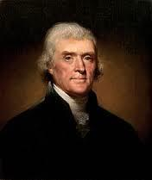
Outcome: Westward Expansion Notes

- Setting the Stage (Background on the West)

  - Americans believed in the idea of _____________ _____________, the idea that it was their God given right to __________ ____________ to the Pacific Ocean and to Mexico

  - President Thomas Jefferson bought the ______________ ____________ from Napoleon Bonaparte of France in 1803 for _______ million
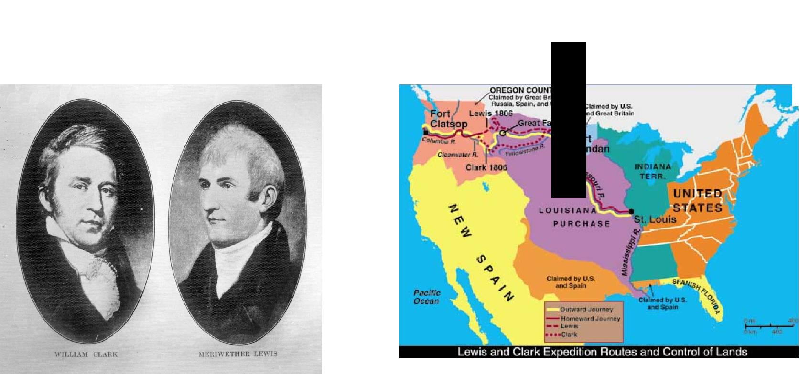

  - Between 1804 to 1806, explorers _________ and _________ were commissioned by President Jefferson to explore west to the Pacific coast

  - The US ____________ __________ in 1845 which led to the Mexican-American war which took place between 1846-1848 and resulted in US obtaining the present day _________________ United States territory from Mexico

  - The ______________________________ with _______________ resulted in the US obtaining Oregon, Washington state, and parts of Wyoming, Montana, and Idaho

  - The United States now stretched from the _____________________________, however, many ___________ _______________ ___________ lived on these newly obtained pieces of land and had called this land home for ________________ of years
- Motivations to settle the West

  - The California ________ _________ of 18____ & the discovery of gold in Colorado in 18____ sparked a wave of settlers to the west hoping to literally strike gold

  - Mining towns were ________ and included _____________ ________________ of every kind including Irish, German, Polish, Chinese, and African Americans

  - _______________! The _______________ _________ of 1862 offered 160 acres to citizens;

_________________ families took advantage of this offer
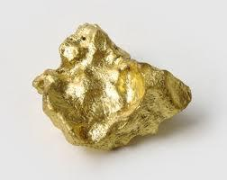

- The Transcontinental Railroad

  - The federal government offered 170 million acres in ________ ___________ to

________________ between 1850-1871

  - Land grants were pieces of land ______________ _____ _______ _______________

____________ to encourage railroad companies to build more railroads westward

  - Two competing companies worked to complete the _____________ _______________

in the United States

  - The _____________________________ moved eastward from Sacramento

  - The _____________________________ moved westward from Omaha, Nebraska

  - Both companies relied heavily on foreign labor such as Irish and mostly

____________________________________

  - The Central Pacific used unstable _______________________ to blast through the difficult terrain of the _____________ ___________________ mountains

  - Both companies reached ____________________ _______________, Utah by 1869 where a ____________ ____________ was driven to hail the completion of the railroad

  - Fifteen years later, the _______ ________ _________ transcontinental railroads

  - The railroads significantly shrunk the size of the US and allowed for settlers to migrate west more _____________ and __________________

- Life in the West

  - Trees were often ____________ so settlers built their homes called sod homes, or

_______________, from the land itself

  - _____________ often worked in the _______________ with men plowing, planting, and harvesting the crops
  - __________________ and __________________ were important for ___________ production

  - Frontier settlers faced many hardships such as ____________, floods, _____________, blizzards, ________________ plagues, and occasional raids by outlaws and

____________ Americans
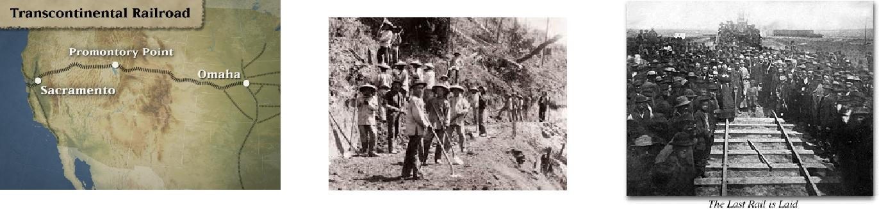
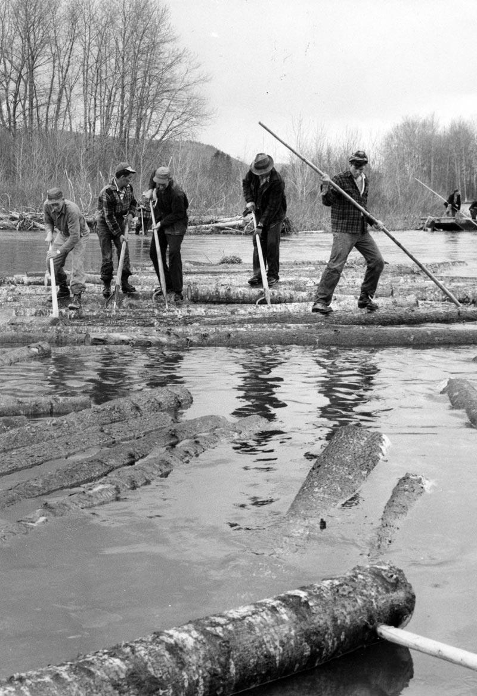
Result: Even though America was now a ___________ nation, _____________ with Native Americans would be the next real challenge & would remind us that there is a

  

