The Persian Empire
550 BC – 300 BC

Growth of an Empire

The Persian Empire was one of the largest in history, at its height it spread from Egypt to the Indus River. Indo-Europeans began settling in the land east of the Fertile Crescent around 1000 B.C.E. In 550 B.C.E., a Persian king named Cyrus began conquering kingdoms. Over time, his empire had grown from Anatolia (Turkey) in the west to the Indus River in the east. The way that Cyrus ruled his empire was very special for that time. He was tolerant of the people he conquered by allowing them to keep their local customs, religion, and language. The Persian Empire was able to control such a
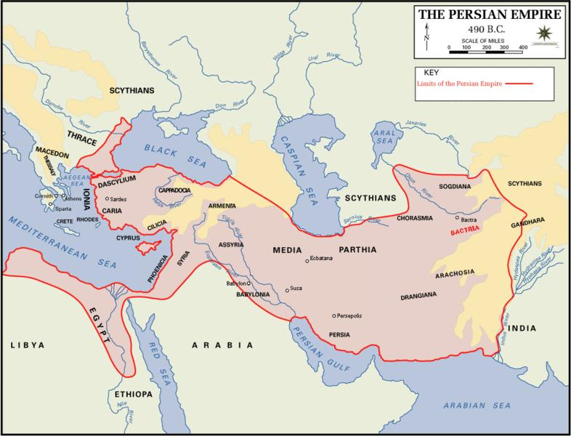
large empire by a well-developed imperial bureaucracy. The empire was divided into various provinces and each province was ruled by a governor called a satrap. In this way the emperor was able to effectively govern such a large empire. This system of bureaucracy has been copied in modern day governments and its influence can be seen in modern American government.

Persian Culture
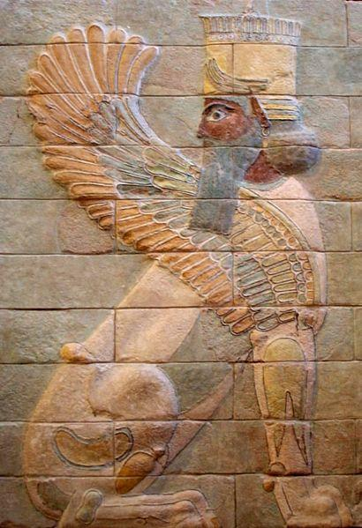
The Persians were also great engineers and built royal roads that connected the empire. These roads encouraged trade, communication, and allowed the military to move quickly. As the Persian Empire spread, it came in contact with Central Asian, Mesopotamian, Arabic, and Egyptian cultures. All of these earlier civilizations contributed to the Persian culture and also allowed it to become the largest empire in the world at that time. A Persian prophet named Zoroaster lived around 600 B.C.E. and taught that there are two opposite forces in the universe, good and evil. Because of this, humans are involved in an endless battle and are expected to participate. The religion believed in one god, Ahura Mazda. They believed that Ahura Mazda would judge people based on how well they fought for the good. Zoroaster’s religious teachings became the basis for Zoroastrianism, and it was the main religion of the Persian empire. Zoroastrianism is still practiced today in parts of Iran, India, Pakistan, and other small areas of the world. This religion has also influenced other religions such as Christianity and Islam.

Key Vocabulary
Height: the high point of something

Imperial Bureaucracy: a government with many local officials working to run the empire Satrap: rulers chosen by the emperor to control a local province

Royal Roads: long roads built by the Persian Empire to easily connect the empire Zoroastrianism: religion started by Zoroaster, and it was the main religion of Persia

Name ___________________________________

Review Questions

- The Royal Roads allowed the Persians to effectively manage their empire. What tools today help governments function well? Why are they helpful?

- All of the following are examples of the Persian Empire except:

  - Tolerance of conquered peoples

  - Extensive road system

  - Imperial bureaucracy

  - Islam
?

    - People could keep their own religion

    - People could keep their own customs

    - People could keep their own language

    - People could keep some of their own laws

- Which is the best title for the table above?

  - Activities in the Persian Empire

  - Desires of conquered people in the Persian Empire

  - Examples of tolerance of conquered peoples in the Persian Empire

  - Living in the Persian Empire

- What is being described by the graphic?

a. | Zoroastrianism
 |  | Monotheistic |  | There is evil |  | Ahura
b. | Christianity
 |  |  |  | in the world |  | Mazda
c. | Islam
d. | Judaism
?

- Choose two of Cyrus’ ideas about government. Explain how these can be an example for leaders of nations today?

